For my discussion assignment I have elected to use the Covid pandemic in a Poisson distribution. I want to estimate the total amount of waves expected in a 5 year period. The number of waves occurring can be modelled as a Poisson distribution as the waves are independent, as there cannot be two or three waves happening simultaneously in South Africa, but only one wave at a time. To create this Poisson distribution, I need to calculate the number of events divided by the interval, multiplied by the interval length. According to the graph below, there is on average a waiting time of about 3 months between each wave, which also lasts about 3 months, which leaves us with an average of 2 waves per year (*South Africa COVID: 3,204,642 Cases and 90,172 Deaths - Worldometer*, 2021). For a period of 5 years, my Poisson distribution would state 2 waves / 1 year \* 5 years = 10 waves which is our lamba rate parameter.

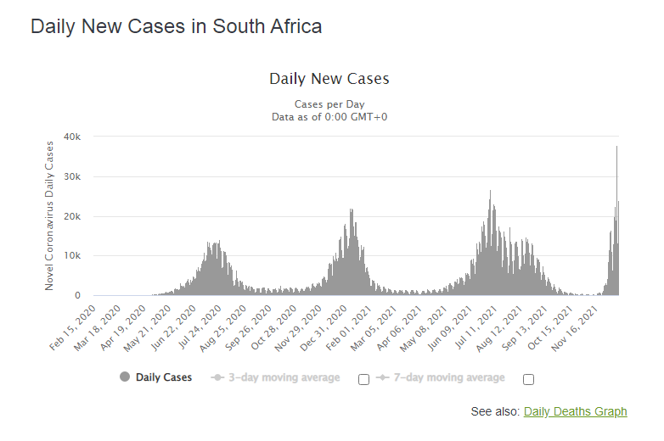

Now to find the probability of hitting a 3rd wave in a year: P(3 in 1 year) = e^-2(2^3/3!)=0.06131 but considering this is a random variable there could be 0 or 10 waves in a year, one is just more or less probable than the other. The importance of having mathematical models such as these is to be able to estimate a guess on things that are random in nature so that proper planning can be made, for example, if we have a high probability of seeing two waves of infections this year, we can calculate how much PPE equipment hospitals should have on hand for the year, and ensure they prepare adequately for 2 waves, not just 1. And if this model shows, for example, that an extra third wave can be expected over winter, they can be warned to acquire extra PPE gear and stack up on some extra face masks, for example.

References:

*South Africa COVID: 3,204,642 Cases and 90,172 Deaths - Worldometer*. (2021). Worldometer. <https://www.worldometers.info/coronavirus/country/south-africa/>

Total Words (337)